DATA STRUCTURES AND ALGORITHM

Exercise 1
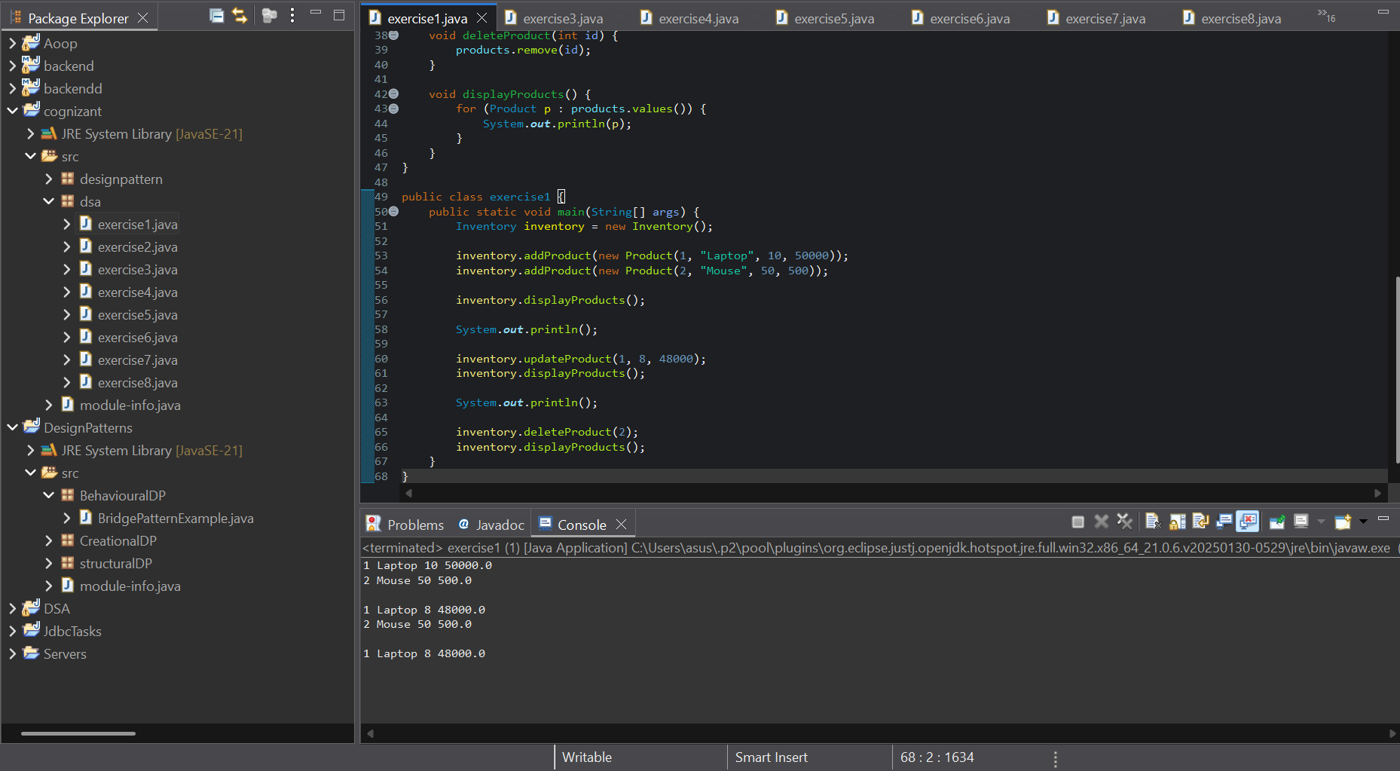
Exercise 2

